**GENERAL HUMAN BIOLOGY – YEAR 11**

**TASK 5 – DIGESTION, NUTRITION AND EXCRETION TEST**

**NAME: ____________________________________ WEIGHTING: 10%**

**DATE: ____________________________________ MARK: _____ / 52 = _____ %**

***MULTIPLE CHOICE SECTION [10 MARKS]***

*Circle the correct answer (ie. a, b, c, or d) next to each question below:*

1. This is the job of the digestive system.

a. To give the body shape

b. To take in and break down food for use in the body

c. To take in oxygen and give off carbon dioxide

d. To excrete metabolic wastes.

2. What organ produces bile in the digestive system?

a. Liver

b. Pancreas

c. Small intestine

d. Stomach

3. Most food is absorbed in the:

a. Small intestine

b. Large intestine

c. Mouth

d. Pancreas

4. A long tube that carries food from the mouth to the stomach.

a. Urethra

b. Trachea

c. Aorta

d. Oesophagus.

5. In the stomach which of the following statements is INCORRECT?

a. Protein is digested

b. Mucous allows the acid to act on the stomach wall.

c. Chyme is formed.

d. Acid kills the bacteria which enters the stomach.

6. The digestive system processes food into usable and unusable materials. The usable materials are sent to the body's cells as food. What happens to unusable materials?

a. It goes into the pancreas to await disposal.

b. It is excreted via the kidney.

c. It is eliminated by the rectum

d. It is absorbed in the small intestine.

7. Which list of functions describes those of the large intestine

a. Absorb bile and useful enzymes, egest wastes, absorb amino acids and fatty acids

b. Remove water, absorb bacteria that produce vitamins, digest cellulose and starch

c. Break down indigestible substances, digest fats and cellulose, absorb useful substances especially water

d. Reabsorption of water, temporary storage of faeces, habitat for bacteria and breakdown of cellulose (plant material) by bacteria.

8. Examples of macromolecules that we ingest are:

a. protein, amino acids, carbohydrates

b. Carbohydrates, simple sugar, glucose

c. Carbohydrates, proteins, lipids

d. Amino acids, glucose, fatty acids

9. What is the role of the kidney in the urinary system of mammals?

1. To remove sugar from the body and to keep water in the body.
2. To remove water from the body and keep salt in the body.
3. To remove nitrogenous waste from the body and maintain water levels in the body.
4. To remove water from the body and maintain levels of nitrogenous substances in the body.

10. Why is there a large amount of protein found in the blood but none in the Bowman’s capsule or urine?

1. The proteins are converted to amino acids before they enter the capsule.
2. The proteins are too large to move through the capsule membrane.
3. The proteins are needed by the body and so are not filtered.
4. The proteins are converted by the capsule into amino acids.

***END OF MULTIPLE CHOICE***

***SHORT ANSWER SECTION [36 MARKS]***

*Write your answers in the spaces provided below*

1. Label the following diagram in the spaces provided.

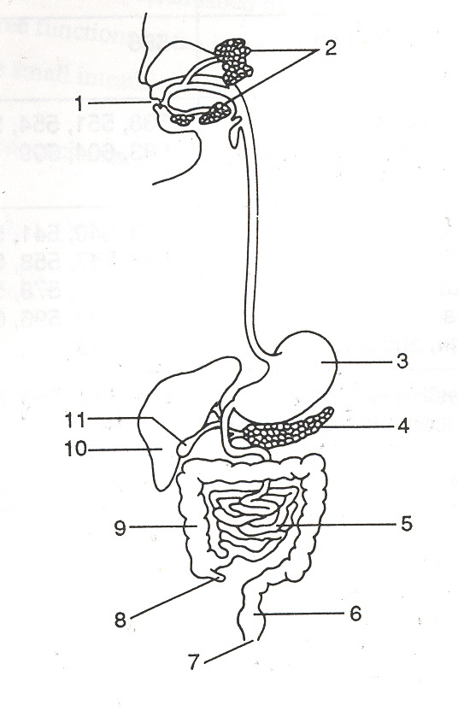

(3 marks)

1. ________________________ 9. ________________________

3. ________________________ 10. ________________________

4. ________________________ 11. ________________________

1. Below is a table with three different foods. Complete the table with the information required about each of the foods. (6 marks)

|  |  |  |  |  |
| --- | --- | --- | --- | --- |
| Food | Food group | What is the simplest form it is broken down into | Enzyme that breaks it down | Where in the body does it **BEGIN** to chemically digest |
| Meat |  |  |  |  |
| Butter |  |  |  |  |
| Fruit |  |  |  |  |

1. The body uses both mechanical and chemical digestion to release nutrients from our food which will eventually be absorbed by our cells.

* 1. Mechanical and chemical digestion starts in the mouth. Compare and contrast these types of digestion. (4 marks)

* 1. Enzymes assist with chemical digestion, explain how enzymes work using diagrams to support your answer. (3 marks)

1. There are 5 essential nutrients we get from the foods we eat, for any 2 state what their function in the human body is: (4 marks)
2. ________________________________________________________________________________________________________________________________________________________________________________________________________________________________________________
3. ________________________________________________________________________________________________________________________________________________________________________________________________________________________________________________
4. Below is a diagram of a structure found inside the kidney

ii.

i.

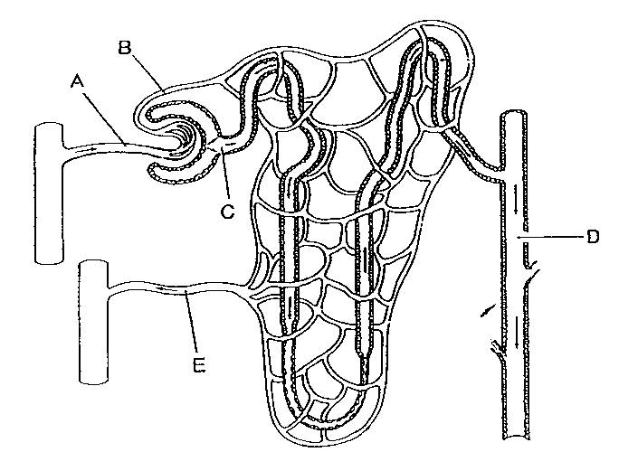

iii.

iv.

* 1. What is the name of this entire structure? (1 mark)
  2. Name the following parts of the above structure. (2 marks)

* 1. Explain the three processes that occur in the above structure. (4 marks)

________________________________________________________________________________________________________________________________________________________________________________________________________________________________________________________________________________________________________________________________________________________________________________________________________________________________________________________________________________________________________________________________________________________________________________________________________________________________________________________________

1. The table below shows the concentrations of dissolved substances in the urine of a healthy person and the urine of a person with one type of kidney disease.

|  |  |  |
| --- | --- | --- |
| Substance | Concentration in grams per dm3 | |
| Urine of a healthy person | Urine of a person with kidney disease |
| Protein | 0 | 6 |
| Glucose | 0 | 0 |
| Amino acids | 0 | 0 |
| Urea | 21 | 21 |
| Mineral ions | 19 | 19 |

* + 1. Suggest an explanation for the difference in composition of the urine between the healthy person and the person with kidney disease. (3 marks)

________________________________________________________________________________________________________________________________________________________________________________________________________________________________________________________________________________________________________________________________________________________________________________________________________________________________________________________________________________________________________________________________________________________________________________________________________________________________________________________________

* + 1. The person with the kidney disease could be treated either by using a dialysis machine or by a kidney transplant operation.

1. Describe each treatment. (2 marks)

________________________________________________________________________________________________________________________________________________________________________________________________________________________________________________________________________________________________________________________________________________________________________________________________________________________________________________________________________________________________________________________________________________________________________________

________________________________________________________________________________

1. Give 2 advantages and 2 disadvantages for each treatment. (4 marks)

____________________________________________________________________________

____________________________________________________________________________

____________________________________________________________________________

____________________________________________________________________________

____________________________________________________________________________

____________________________________________________________________________

____________________________________________________________________________

____________________________________________________________________________

***END OF SHORT ANSWERS***

***EXTENDED ANSWER SECTION [6 MARKS]***

1. You have been given a separate piece of paper that contains the suggested servings per day of each of the Five Food Groups and examples of what is considered one serving.   
     
   Using the information on the sheet, create a healthy food plan for a **14-18 year old male student**. The plan is for one day only.

___________________________________________________________________________________________________________________________________________________________________________________________________________________________________________________________________________________________________________________________________________________________________________________________________________________________________________________________________________________________________________________________________________________________________________________________________________________________________________________________________________________________________________________________________________________________________________________________________________________________________________________________________________________________________________________________________________________________________________________________________________________________________________________________________________________________________________________________________________________________________________________________________________________________________________________________________________________________________________________________________________________________________________________________________________________________________________________________________________________________________________________________________________________________________________________________________________________________________________________________

___________________________________________________________________________________________________________________________________________________________________________________________________________________________________________________________________________________________________________________________________________________________________________________________________________________________________________________________________________________________________________________________________________________________________________________________________________________________________________________________________________________________________________________________________________________________________________________________________________________________________________________________________________________________________________________________________________________________________________________________________________________________________________________________________________________________________________________________________________________________________________________________________________________________________________________________________________________________________________________________________________________________________________________________________________________________________________________________________________________________________________________________________________________________________________________________________________________________________________________________

____________________________________________________________________________________________________________________________________________________________________________________________________________________________________________________________________________________________________________________________________________________________________________________________________________________________________________________________________________________________________________________________________________________________________________________________________________________________________________________________________________________________________________________________________________________________________________________________________________________________________________________________________________________________________________________________________________________________________________________________________________________________________________________________________________________________________________________________________________________________________________________________________________________________________________________________________________________________________________________________________________________________________________________________________________________________________________________________________________________________________________________________________________________________________________________________________________________________________________________________

________________________________________________________________________________________________________________________________________________________________________